ST. XAVIER’S COLLEGE

(Affiliated to Tribhuvan University)

Maitighar, Kathmandu



**Computer Network Lab Assignment #3**

**SUBMITTED BY:**

Pradeep Dahal

017BSCIT029

2nd Year/4th Sem

|  |  |
| --- | --- |
| **Mr. Sanjay Kumar Yadav**  **(Lecturer)** |  |
| **Department of Computer Science** | |

**OBJECTIVE: BASIC ROUTER CONFIGURATION**

**REQUIREMENTS:**

1. CISCO Packet Tracer
2. Router
3. Switch
4. Straight cables
5. Console cables

**THEORY:**

Routers are small physical devices that join multiple networks together. Technically, a router is a Layer 3 gateway device, meaning that it connects two or more networks and that the router operates at the network layer of the OSI model.

Home networks typically use a wireless or wired Internet Protocol (IP) router, IP being the most common OSI network layer protocol. An IP router such as a DSL or cable modem broadband router joins the home’s local area network (LAN) to the wide-area network (WAN)of the Internet. By maintaining configuration information in a piece of storage called the routing table, wired or wireless routers also can filter traffic, either incoming or outgoing, based on the IP addresses of senders and receivers.

An Internet Protocol address (IP address) is a numerical label assigned to each device (e.g., computer, printer) participating in a computer network that uses the Internet Protocol for communication. An IP address serves two principal functions: host or network interface identification and location addressing.

Static routing is useful in small network where numbers of routes are limited. In static routing we need to add route manually with IP route command. Like other routing methods static routing also has its pros and cons.

Advantage of static routing

1. It is easy to implement.
2. It is most secure way of routing, since no information is shared with other routers.
3. It puts no overhead on resources such as CPU or memory.

Disadvantage of static routing

1. It is suitable only for small network.
2. If a link fails static route cannot reroute the traffic.

Static IP addressing is for one customer on one IP address. Static IP addresses are more reliable for Voice over Internet Protocol (VOIP), more reliable to host a gaming website or to play X-Box, Play Station, use Virtual Private Network for secure access to files from your company network computer, etc. Static IP addresses are also great if we use your computer as a server, as it should give our file server faster file uploads and downloads.

**PROCEDURE:**

Step 1: Configure Router Basics form HyperTerminal

Select a router and an end device (Laptop 0) as in figure below:

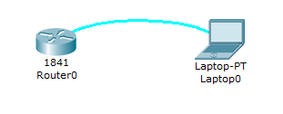

Connect the router and the laptop through Console cable by left clicking the router and choosing “Console” and then left clicking the Laptop 0 and choosing “RS 232”.

Step 2: Now select a Switch and connect it to the router through Straight through cable by left clicking the router and choosing “FastEthernet 0/1” and then left clicking the switch and choosing “FastEthernet 0/1”.

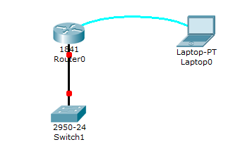

Step 3: Configure the Computer terminal software

Now to configure the Router 0, click on Laptop0 and then goto desktop and to Terminal Configuration.

The terminal software in not correctly configured on the laptop. You have to change the settings to 9600 / 8 / None to connect to the router's console and click ok.

A screenshot of a cell phone

Description generated with very high confidence

A screenshot of a social media post

Description generated with very high confidence

The terminal opens and for the question “Continue with configuration dialogue?” type no and enter.

Step 4: Now enable the router using “enable” command.

When you boot up your Cisco router for the first time, you notice some basic configuration has already been performed. Use the show running-config command to view the initial configuration, as shown in the following example.

A screenshot of a cell phone

Description generated with very high confidence A screenshot of a social media post

Description generated with very high confidence

A screenshot of a social media post

Description generated with very high confidence

Step 5: Configure the global parameters for router and ethernet interfaces

1. configure terminal

2. hostname name (Configure the router's name)

A screenshot of a social media post

Description generated with very high confidence

3. interface fastEthernet *slot/port* (interface fastEthernet 0/1 command is used to enter in interface mode.)

4. ip address *ip-address* mask (ip address 192.168.1.1 255.255.255.0 command will assign IP address to interface and subnet mask for the specified fastEthernet interface.)

5. no shutdown (Enables the fastEthernet interface, changing its state from administratively down to administratively up)

After configuring the router, again check the configuration by using running-config command to find the latest configuration made in router.

A screenshot of a cell phone

Description generated with very high confidence A screenshot of a cell phone

Description generated with very high confidence

Step 6: exit (Exits configuration mode for the fastEthernet interface and returns to global configuration mode.)

A screenshot of a cell phone

Description generated with very high confidence

Step 7: After the router has been configured and it’s ip address has been configured, we can see that the link lights between the router and the switch turns green.

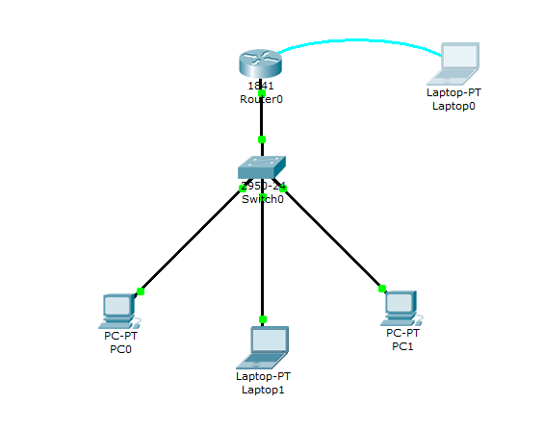

Now connect a number of end devices in the switch through straight through cables by clicking on switch and selecting fastEthernet 0/2 or 0/3 for different end deviced and then clicking on end devices and choosing “fastEthernet”.

Step 7: Configure IP addresses for the end devices.

A screenshot of a cell phone

Description generated with very high confidence

Step 8: Now to check the configuration, ping the end devices.

Network connectivity and communication can be tested using a ping command, followed by the domain name or the IP address of the device (equipment) one wishes to test connectivity to.

A screenshot of a cell phone

Description generated with very high confidence

It is observed that the network is performing well, as we can see that we are getting reply from the domain 192.168.1.1.

**CONCLUSION:**

Hence by using the CISCO Packet Tracer, we performed basic router configuration and IP address configuration.